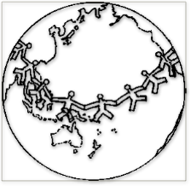West East Missions

HANDCLASP

Benefits The Needy People Of Asia

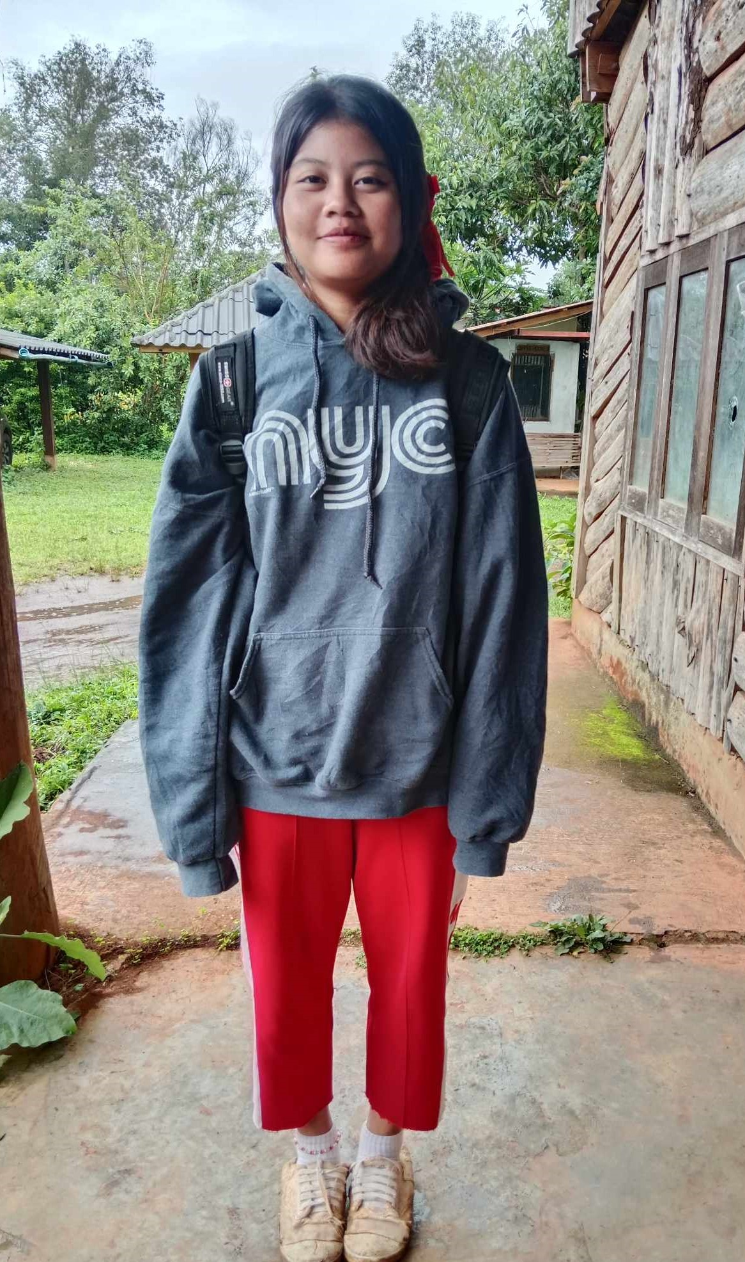

Child's Name Matheena Ben  First Middle Last

Name of Orphanage, Child Care Center or School caring for the child

Musekee Child Care Programme

Date of Birth 17.May 2008 (16 yrs ) Gender F Day/month/Year

115 Height 158 cm Weight 49 kg

Religion Christian Church Nil

School Sahamitvitaya Grade or year

Favorite subject Physic

Ambition in life Nurse

**PARENTS**

Father's Name Mr.Chochhae Age Occupation Labor approximate USD per Month

Mother Mrs.Fa Age 40 Occupation Nil Income USD per month

**Brothers and Sisters**

Name Gender Age Occupation Ed. Level Name of School

1. Matheena Ben F 16 student Gr,10 Sahamitvitaya

2 Kaneeka F 14 No school (Handicapped)

3.

FAMILY BACKGROUND

Matheena Ben was borned in a Karen Tribe family, Mother is a Christian, father is Budhist , Mother left father when she was a child and re-married with new guy. When she was about 8 yrs old, her father lost his sight not able to see, she come from a very poor family.

**OTHER INFORMATIONS**

Thai and Myanmar border is always confusing, the karen live in Kaw Thoo Lei, karen State, in Myanmar. So many karen people have to leave their home because of the war, live at the border line from Maehongson Province to Chumpon province. There are many karen people migrated to 36 countries with the help of many organization. So many families are separated because of the bad situation of the war in Myanmar. It is effected to the many children lives, confusing and more and more young people are addicted to drugs. Need help to rescue them, giving them education to help themselves and help their own people in the future.